# Modis Stretch

## Purpose

The NRS developed IDL extension Timesat needs scaled NDVI values in the range 0..255 (bytes). The MODIS products (MOD13, MYD13) contain floating point numbers, with a scale factor.

This module allows the scaling from float to byte and vice versa. The scale factor is optional.

## Installation

Install the .SAV files and the .PRO file in the save_add folder (see also [ENVI .sav files: Installation and configuration](http://www.itc.nl/personal/nieuwenh/installations.html).

modis_stretchgui.sav The conversion software

nrs_utils.sav Utility routines

nrsmenu.pro Add menu to ENVI

## Usage

Starting is possible from the command line:

modis_stretchgui

, or from the ENVI menu ‘NRS | Modis stretch, which starts the following dialog (see below):

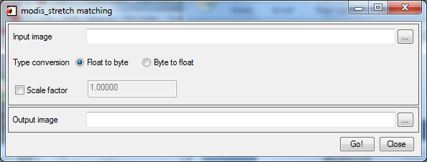

The input image can be single or multi-band: all available bands are processed. Upon selecting an input image, the software will suggest an output image name. If the name is not suitable it still can be changed.

The direction of the scaling can be from float to byte, or from byte to float

Optionally a scale factor can be provided.

The formula calculated:

Float to byte: $out=\left(in*scale_factor*200\right)+ 50$

Byte to float: $out=\frac{\left(in-50\right)}{(scale_factor*200)}$

The formula is based on information from <http://www.glcf.umd.edu/data/ndvi/description.shtml> (the product guide: <http://www.glcf.umd.edu/library/guide/techguide_ndvi.pdf>)